**WORLD SPACE WEEK 2023**

**Iraq**

**NATIONAL REPORT**

**1. General Information**

**National Coordinator:**

Full Name: Eyad S. Khailany

Contact Information (Email, Phone):

[eyadkhailany@gmail.com](mailto:eyadkhailany@gmail.com)

+967 750 817 2 969

**2. World Space Week 2023 (Iraq) Overview**

**Total Number of Events Conducted: 7**

**Nature of Events**

competitions, school events, visual observation, etc.

**Summary of Events:**

Brief overview of the events and their impact:

The number of registered events went from 3 in 2022 to 7 events for the WSW Iraq 2023. Though still the number id still below expected, yet this dramatic increase in the interest in WSW event could be promising. All 7 events were successful and worth the efforts. The number is growing among young youth and the grownups simultaneously.

**3. Highlighted Events and Stories**

**1.**

**Event Details**

**Event Name:** Astronomy for All

**Description:** Astronomy event at an international school

**Location:** Erbil, Iraq

**Date and Time:** from 4-10 October, 2023

**Nature of Event** competition, school event, meeting the local astronomer and telescope observation.

**Number of Participants (if available): 140**

Breakdown by Age Group: 75% people of ages 8 -14 years old.

Breakdown by Gender: 55 % male 45% female

**Notable Stories:**

The younger kids unexpectedly showed great enthusiasm and asked many seriously challenging questions about space.

**Links to Event Coverage:**

<https://www.facebook.com/Cedarsschoolerbil/videos/836479618169298>

<https://www.facebook.com/Cedarsschoolerbil/videos/234663576023889>

**Photos:**

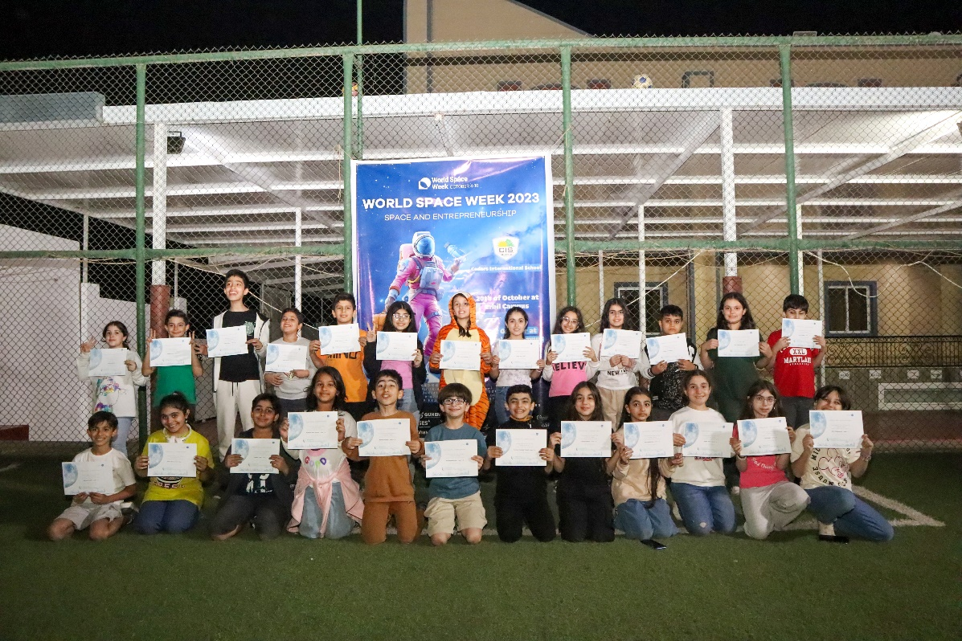

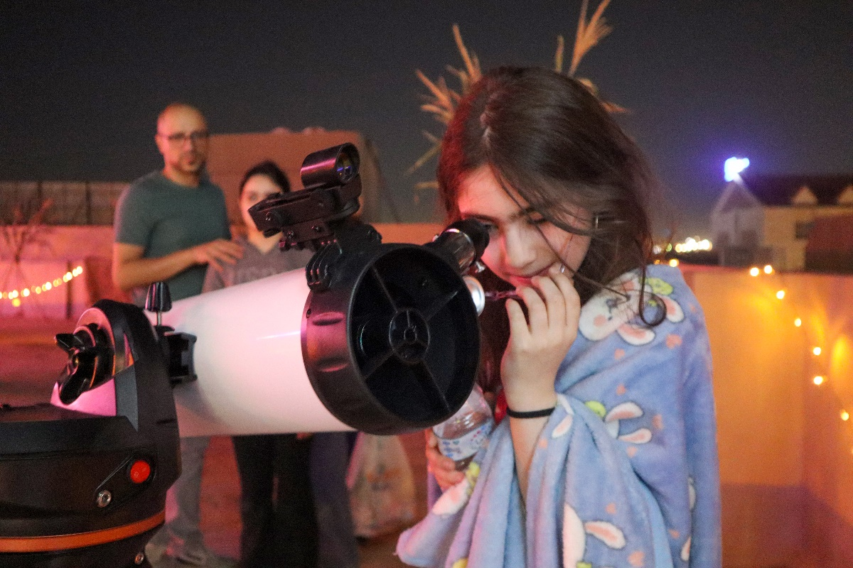

From the WSW Iraq 2023 **Astronomy for All** at the Cedars International School in Erbil, Iraq

**2.**

**Event Details**

**Event Name:** Astronomy for All

**Description:** Astronomy event at an international school

**Location:** Sulymania, Iraq

**Date and Time:** from 6th – 7th October, 2023

**Nature of Event competition,** school event, meeting the local astronomer and telescope observation.

**Number of Participants (if available):** 67

**Breakdown by Age Group (if available):** 70% people of ages 6 -10 years old.

**Breakdown by Gender:** 38 % male 62% female

**Notable Stories:**

The younger kids unexpectedly showed great enthusiasm and asked many seriously challenging questions about space.

**Links to Event Coverage:**

<https://www.facebook.com/Cedars.Sulaymaniyah/videos/696419465748257>

**Photos:**

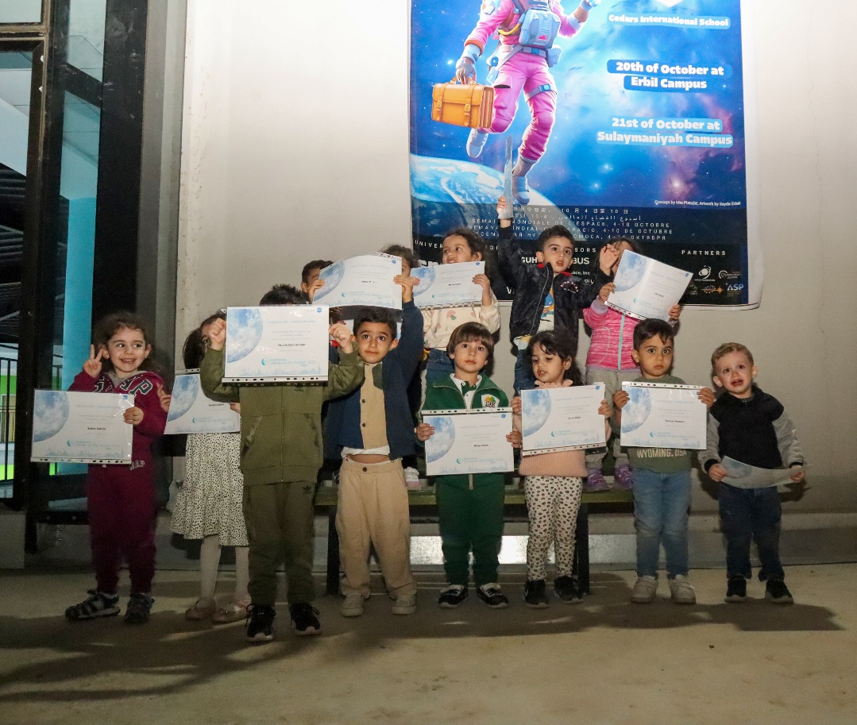

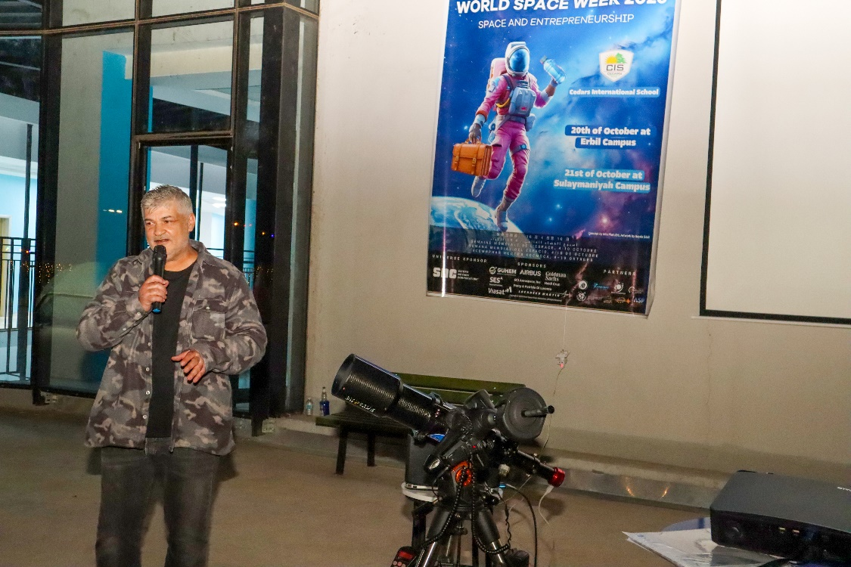

From the WSW Iraq event **Astronomy for All** at Cedars International School, Sulymania

**3.**

**Event Details**

**Event Name:** Galactic Gaming and Cosmic Craft

**Description:** Space-themed games, Space-themed crafts, Guest speakers from the local astronomy community

**Location:** Erbil, Iraq

**Date and Time:** from 10th October, 2023

**Nature of Event competition,** Games and educationalgathering

**Number of Participants (if available):** 56

**Breakdown by Age Group (if available):** 100% people of adults.

**Breakdown by Gender:** 70 % male 30% female

**Notable Stories:** N/A

**Links to Event Coverage:**

<https://www.facebook.com/thestation.erbil/>

**Photos:**

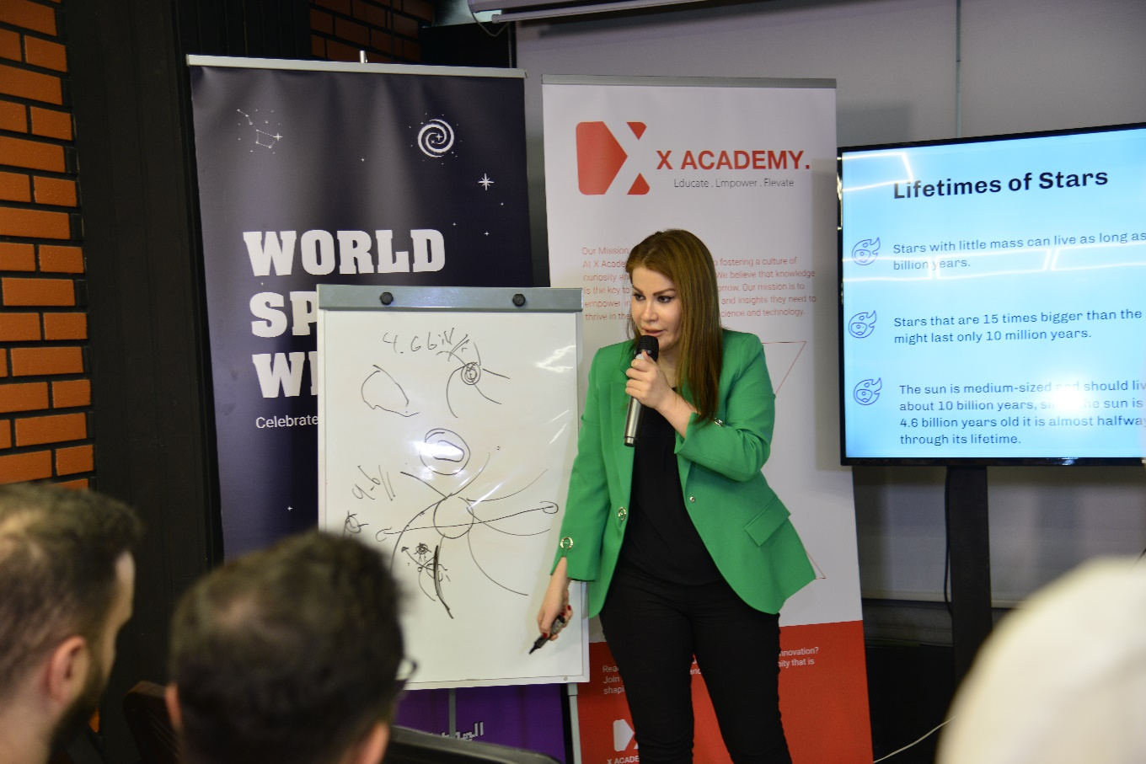

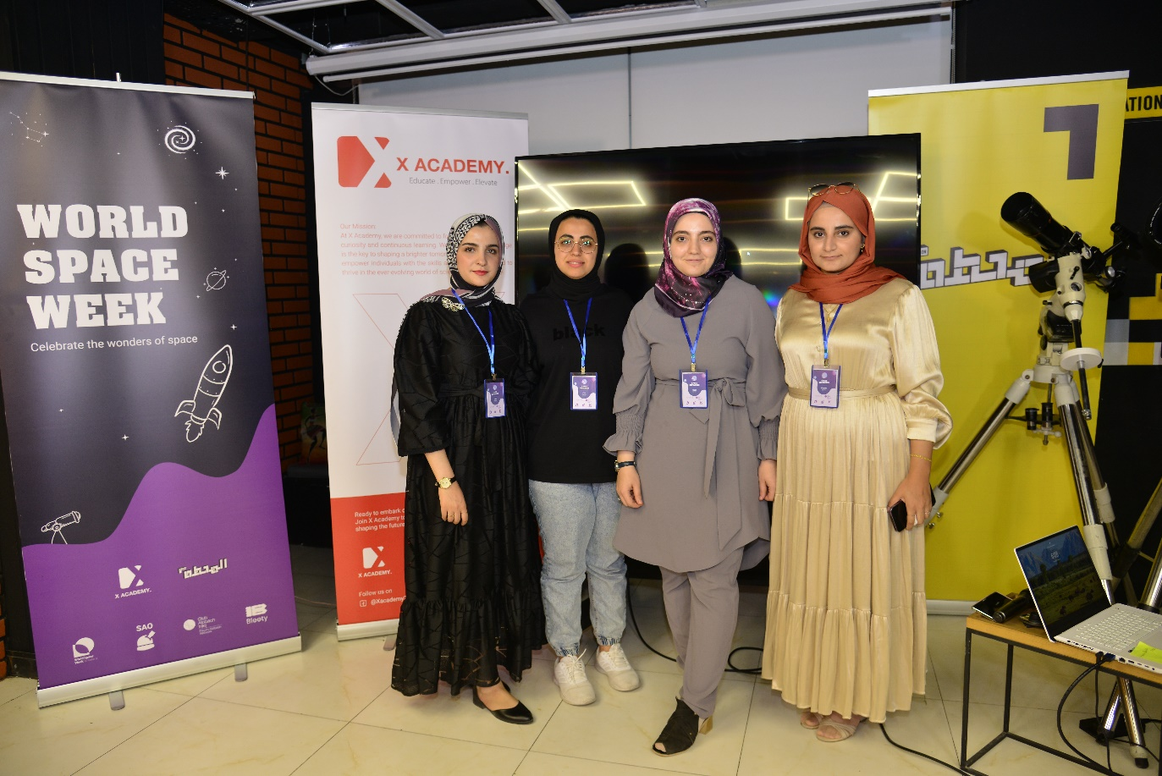

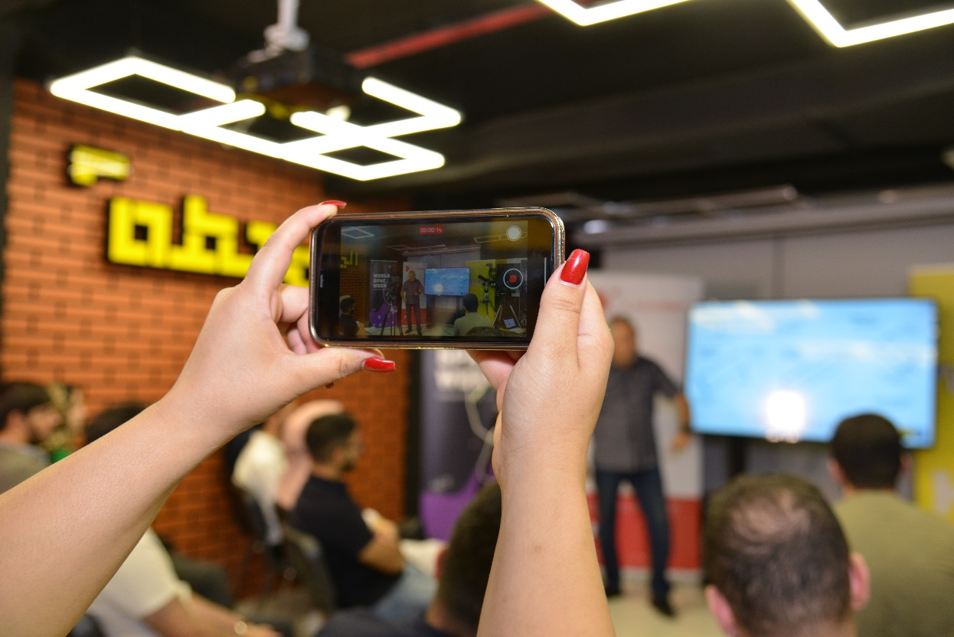

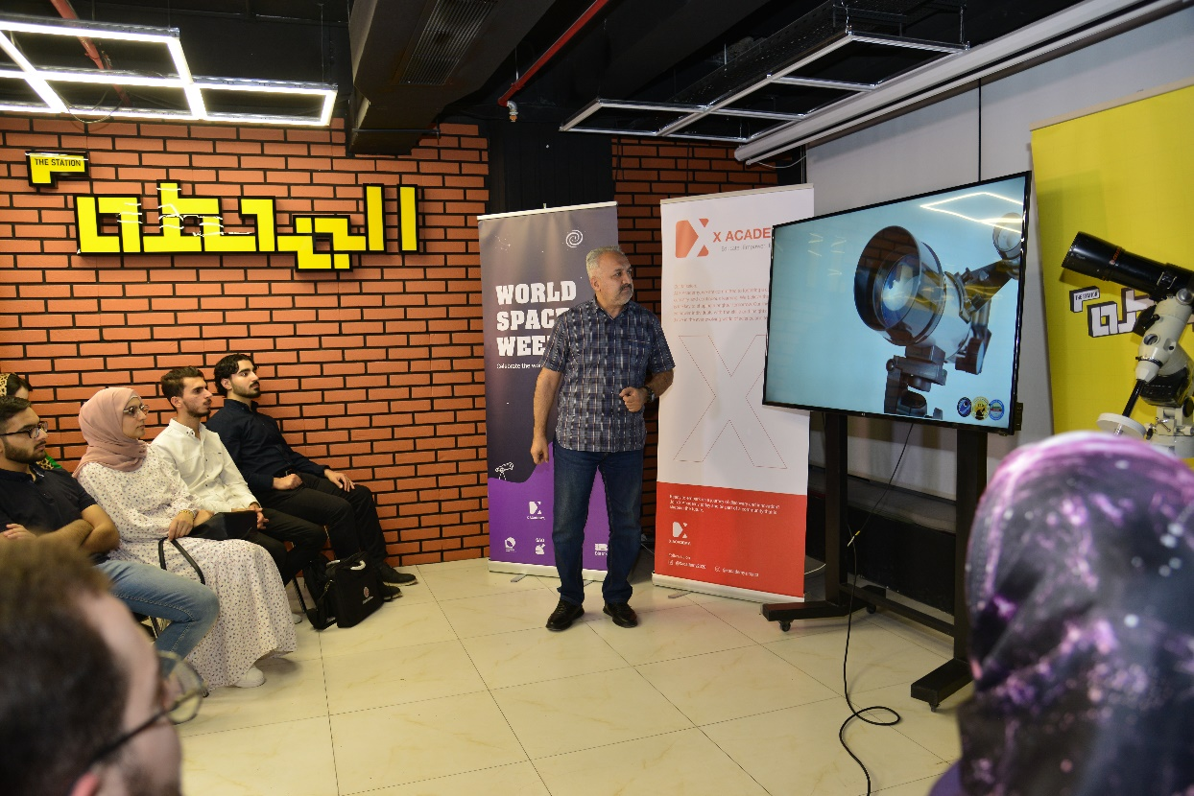

**4.**

**Event Details**

**Event Name:** Solar safety and Observation

**Description:** Partnering Baghdad Dome Astronomical team, the Physics Dept. at the University of Mustansiriyah gave a lecture on the effect of solar radiation on the health and safety of human. The gathering also included a direct solar observation through a telescope with proper solar filter

**Location:** Baghdad, Iraq

**Date and Time:** from 9th October, 2023

**Nature of Event** Lectures and direct solar observation

**Number of Participants (if available):** 126

**Breakdown by Age Group (if available):** 100% people of adults.

**Breakdown by Gender:** 60 % male 40% female

**Notable Stories:** N/A

**Links to Event Coverage:** N/A

**Photos:**

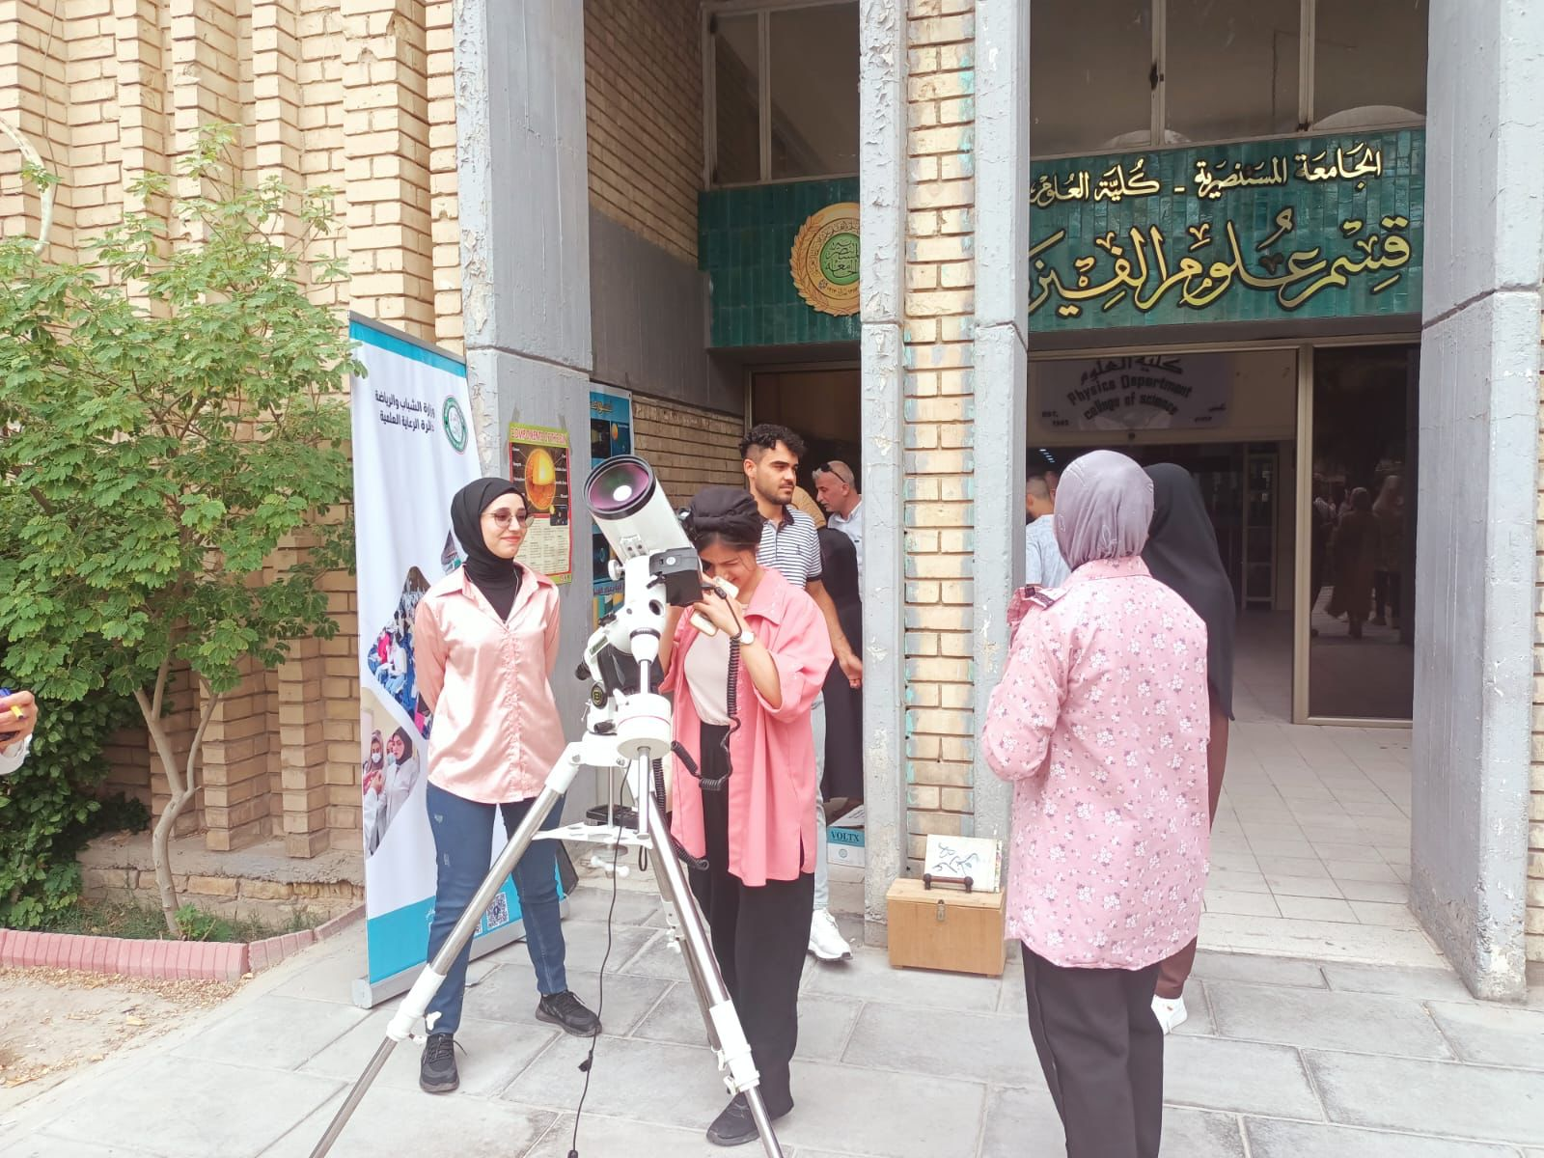

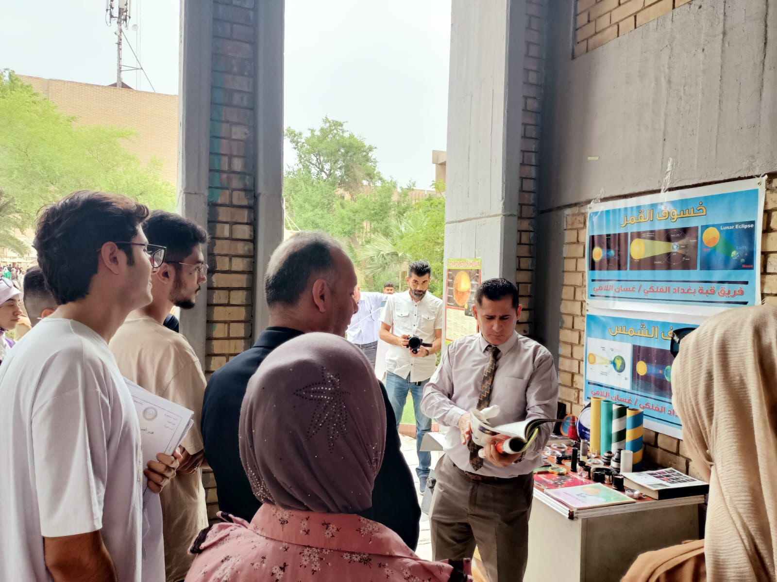

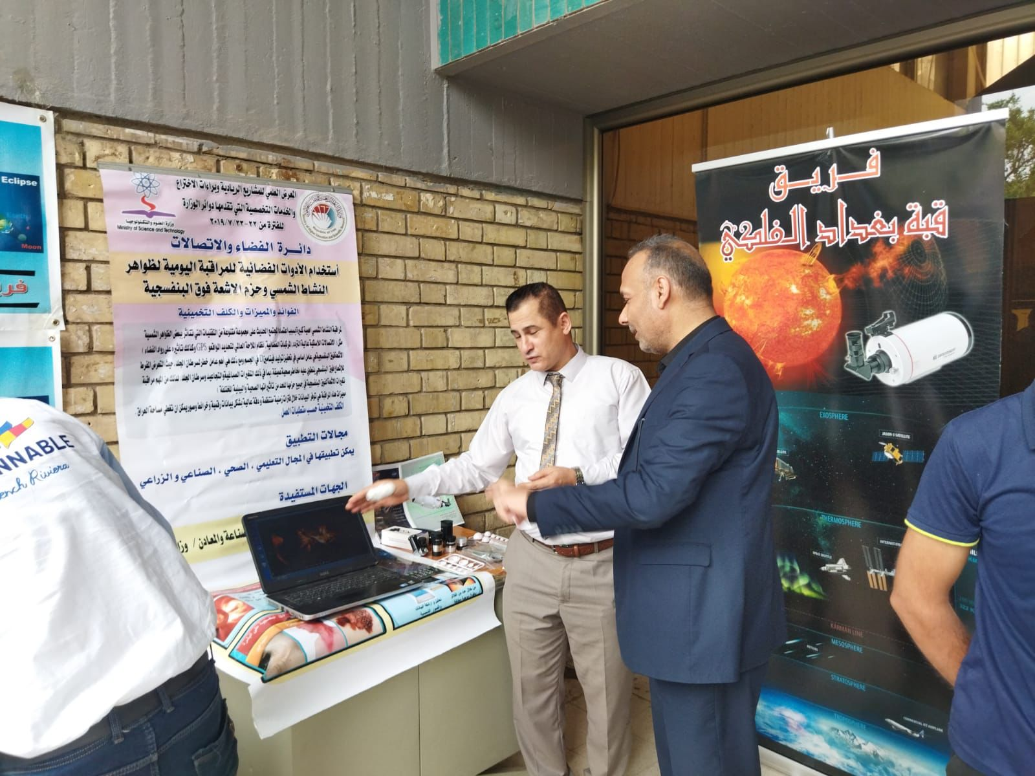

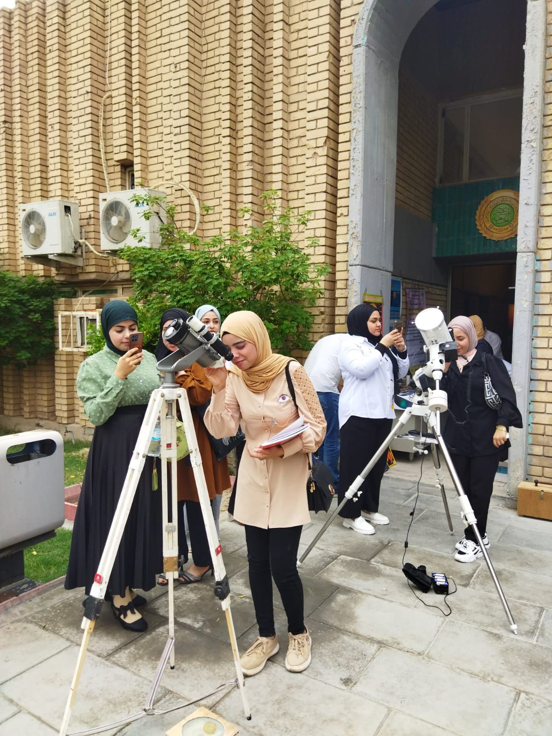

**5.**

**Event Details**

**Event Name:** Our Solar System

**Description:** The event started with a brief intro to the solar system; mainly planets Jupiter and Saturn apart from the Moon. Later on, three telescopes were made available to the public to enjoy direct observation of the two planets and the various lunar terrains.

**Location:** Al-Qādisiyyah Governorate, Iraq

**Date and Time:** from 7th October, 2023

**Nature of Event:** Educational and observational

**Number of Participants (if available):** 87

**Breakdown by Age Group (if available):** 35% people of adults.

**Breakdown by Gender:** 75 % male 25% female

**Notable Stories:** N/A

**Links to Event Coverage:** N/A

**Photos:**

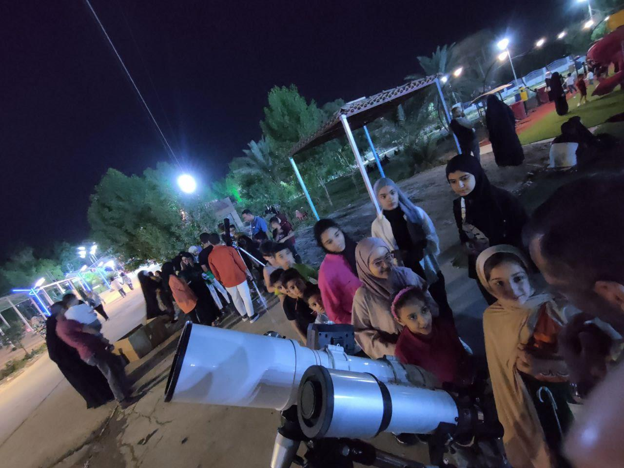

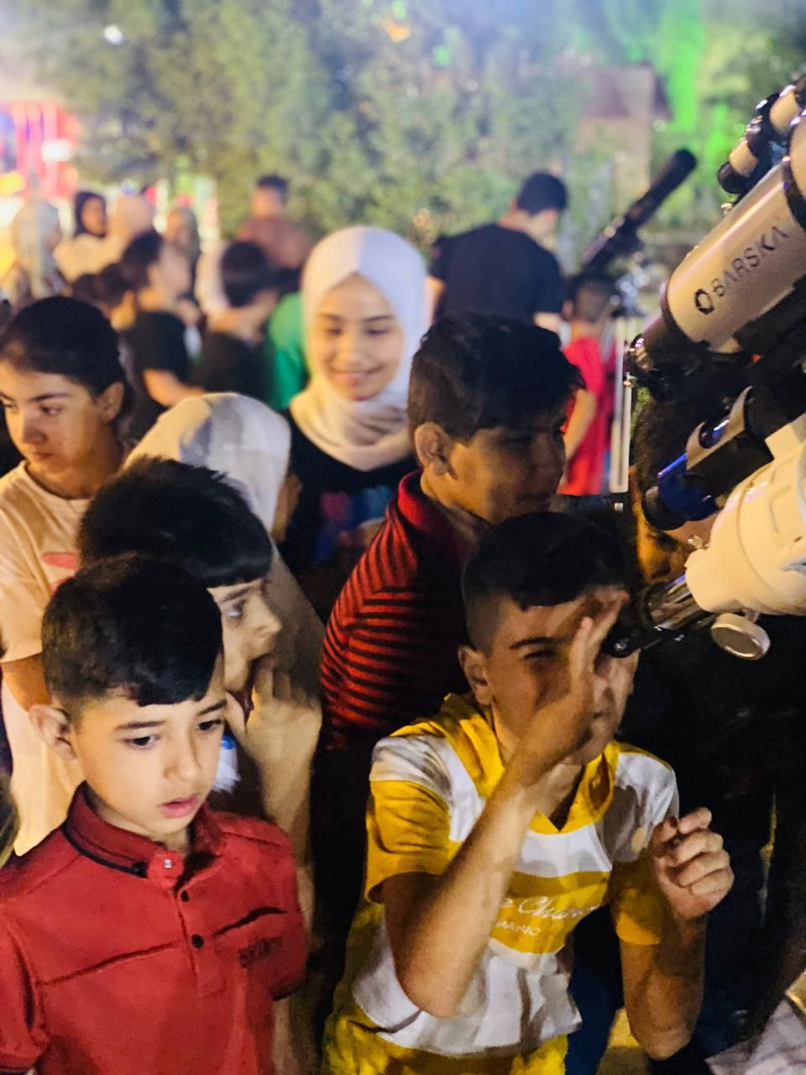

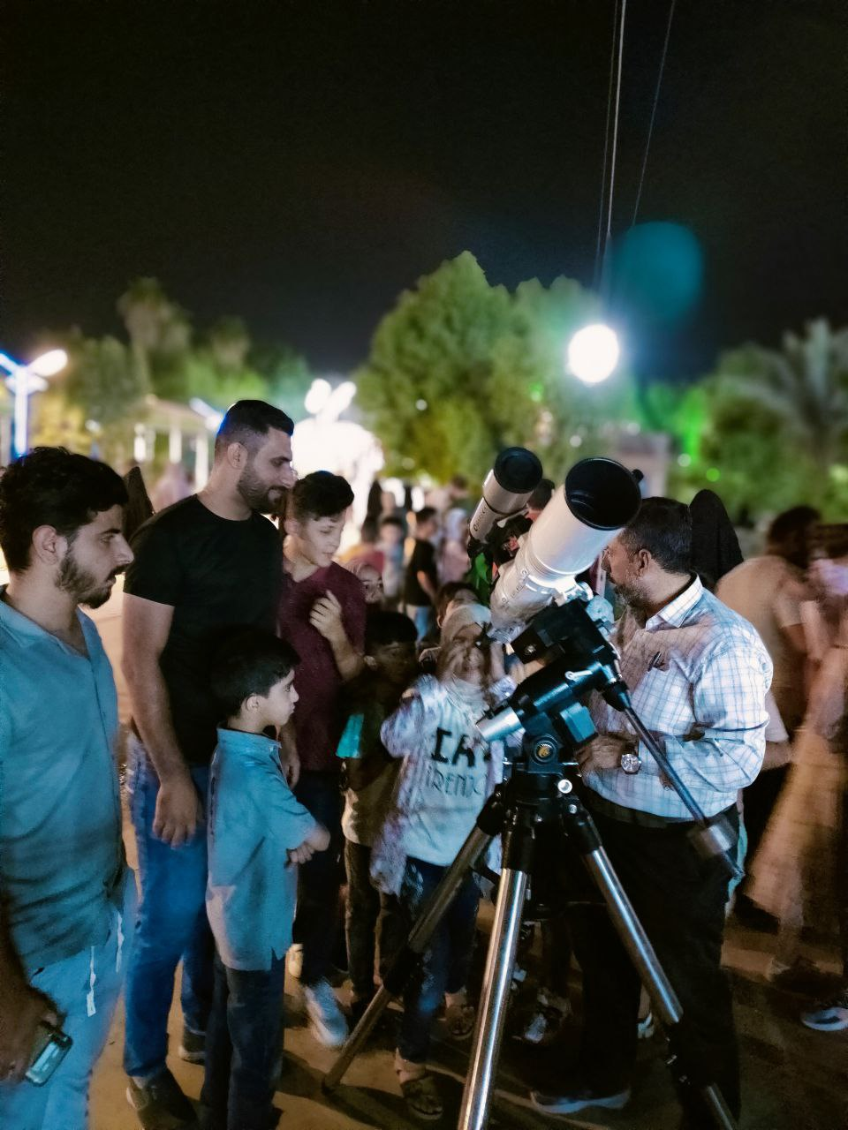

**6.**

**Event Details**

**Event Name:** World Space Week Iraq Dark Sky Camping in Al Dijaily District with Wasit Astronomical Society

**Description:** Wasit Astronomical Society is a highly professional entity mainly dedicated to astrophotography in bortle 3- skies. To celebrate the WSW 2023, the society called its members to camp under the clear sky of this area fully equipped to image numerous DSO's. The camping was a hit as usual.

**Location:** WasitGovernorate, Iraq

**Date and Time:** from 6th October, 2023

**Nature of Event:** Professional Astrophotography

**Number of Participants (if available):** 31

**Breakdown by Age Group (if available):** 100% people of adults.

**Breakdown by Gender:** 100 % male 0% female

**Notable Stories:** N/A

**Links to Event Coverage:**

<https://www.facebook.com/groups/501690684137863>

**7.**

**Event Details**

**Event Name:** Local Observation of Jupiter and Saturn

**Description:** A small public event in a local park in Al Yarmouk district in Baghdad, through which a telescope will be made available for viewers to observe the giant gaseous planets of Jupiter and Saturn in celebrating the WSW 2023.

**Location:** Baghdad, Iraq

**Date and Time:** from 10th October, 2023

**Nature of Event:** Open public observation through a telescope

**Number of Participants (if available):** 42

**Breakdown by Age Group (if available):** 45% people of adults.

**Breakdown by Gender:** 75 % male 25% female

**Notable Stories:** N/A

**Links to Event Coverage:** N/A

**Photos:**

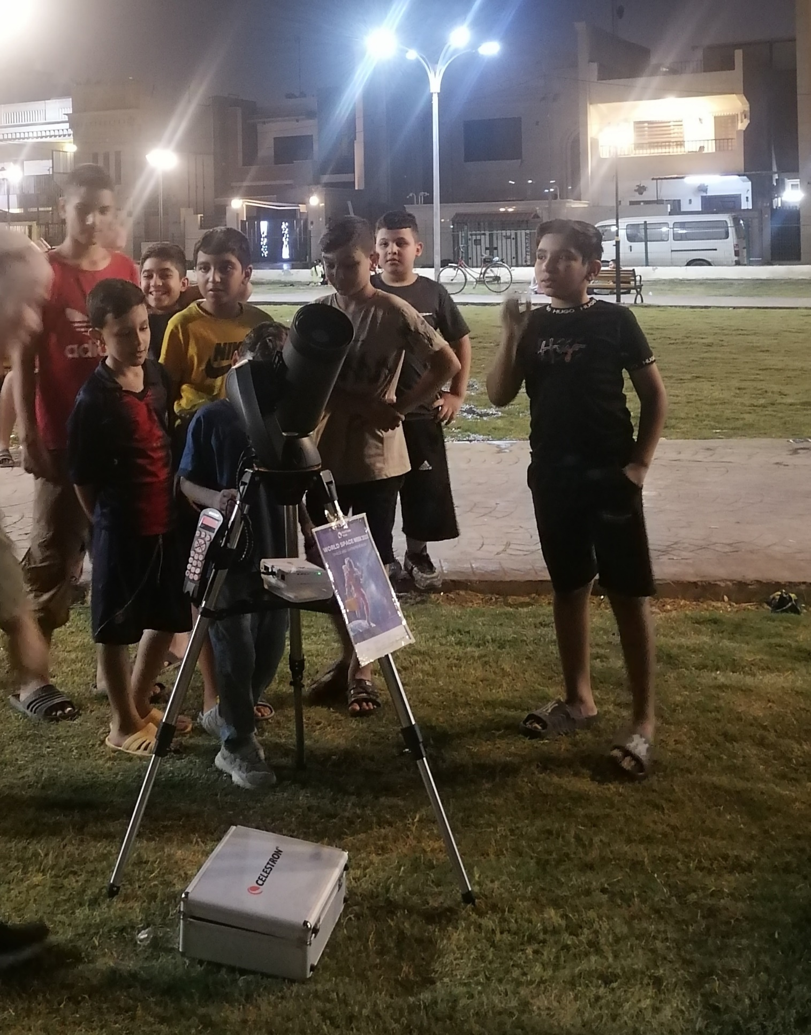

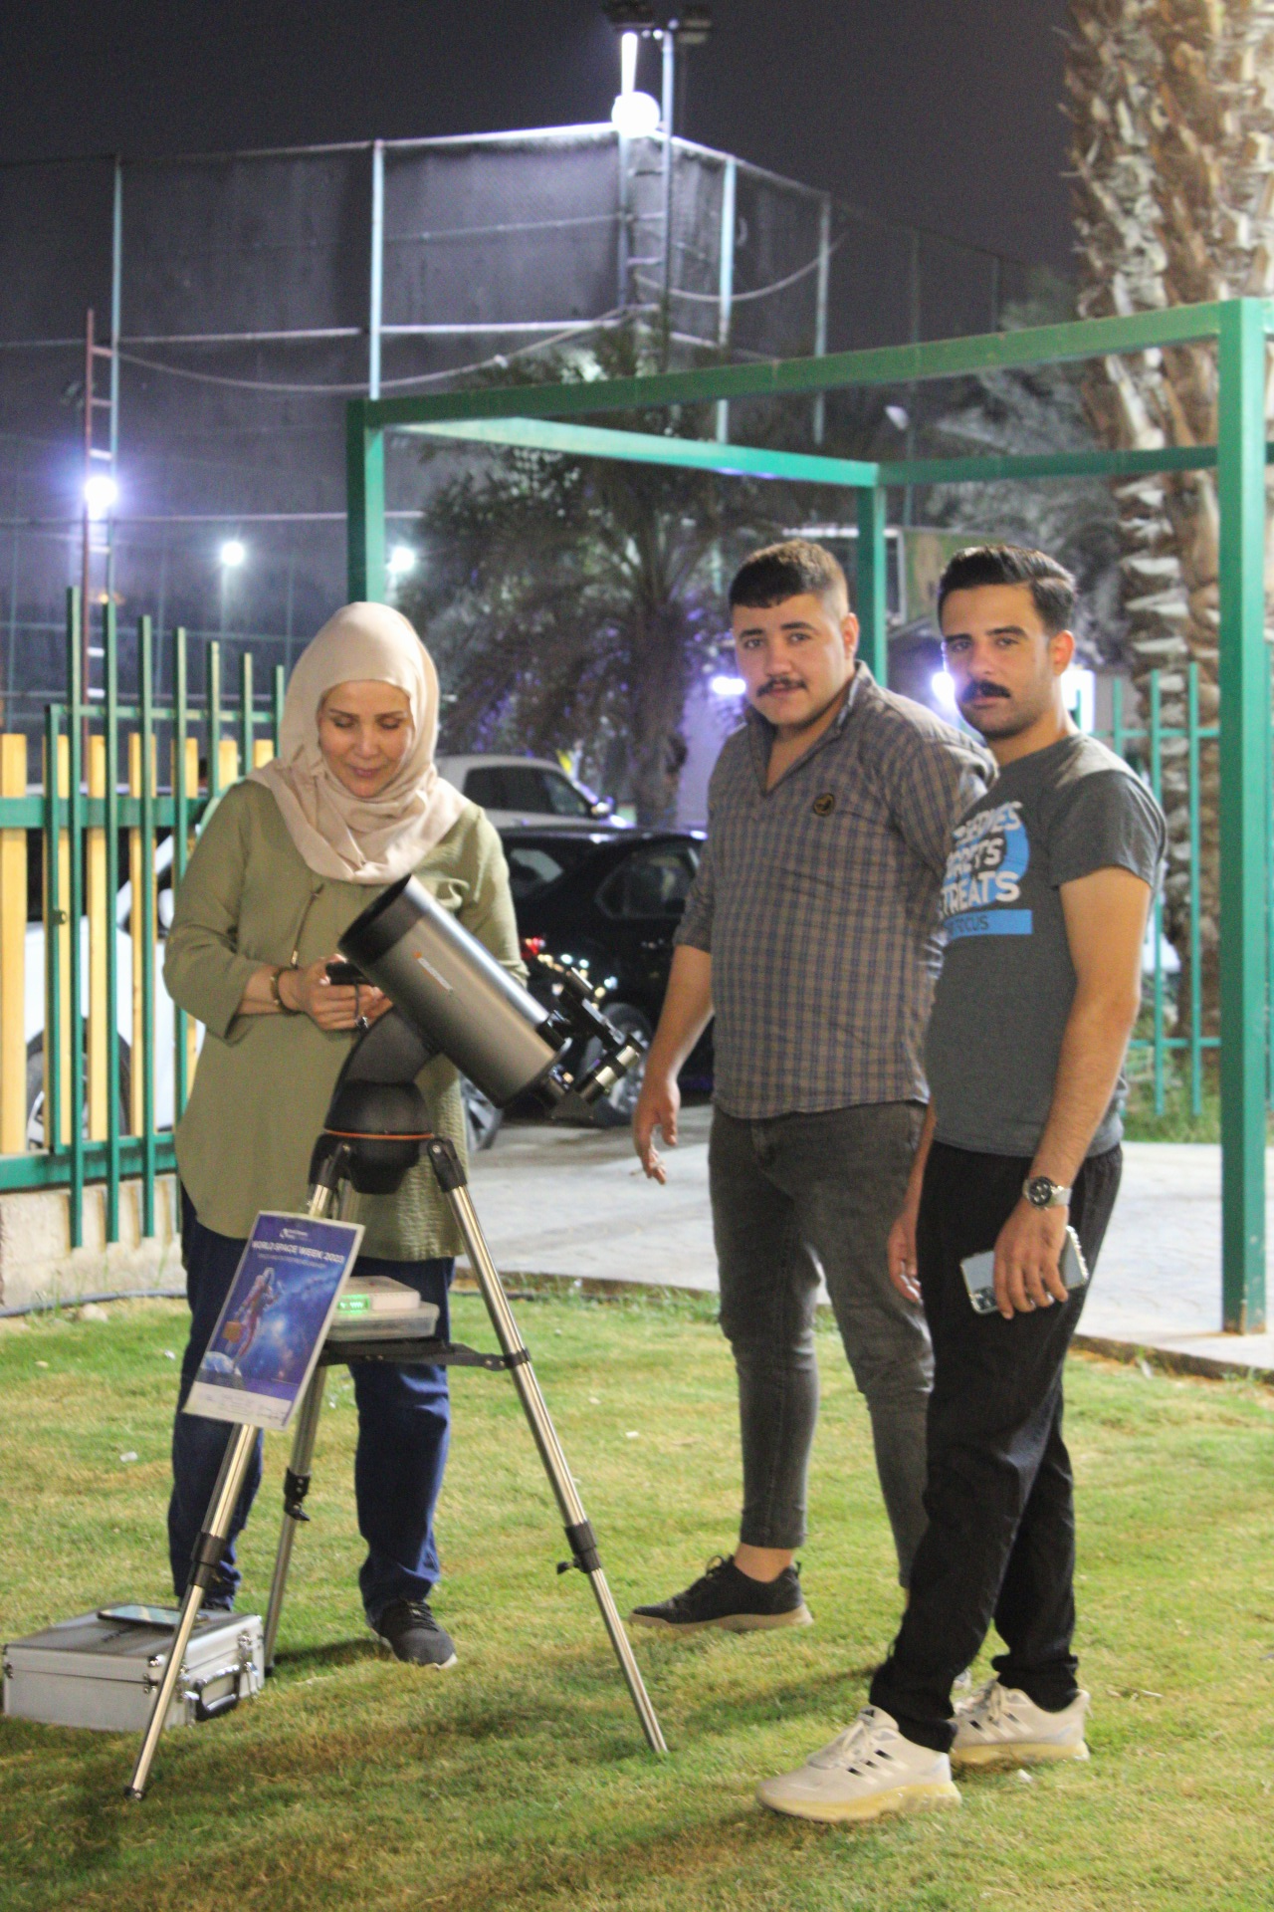

**4. Media and Social Media Engagement (if available)**

**Social Media Impressions**

Please provide a platform-wise breakdown:

**Media / News Coverage:**

You may list as many as possible / available.

Reach (Local, National):

**5. Additional Efforts (if available)**

**1. Press Releases:**

Details of press releases or other promotional efforts undertaken by the NC.

**2. Additional Information:**

Any other relevant information or notable achievements.

